Practical File

Of

**Fundamentals of C Programming**

**23CS003**

***Submitted***

***In partial fulfillment for the award of the***

***degree of***

**BACHELEOR OF ENGINEERING**

***in***

COMPUTER SCIENCES & ENGINEERING



**CHITKARA UNIVERSITY**

**CHANDIGARH-PATIALA NATIONAL HIGHWAY**

**RAJPURA (PATIALA) PUNJAB-140401 (INDIA)**

**June,2024**

**Submitted To: Submitted By:**

**Ms.Prabhjot Kaur Jashanpreet kaur**

**Assistant Professor 2310991522**

**Chitkara University 2nd Semester, G-17**

INDEX

|  |  |  |  |
| --- | --- | --- | --- |
| ***Sr. No.*** | ***Practical*** | ***Date of Practical*** | ***Signature*** |
| 1. | Write a Program to show the use to input (Scanf)/output (Printf) statements and block structure of C-program by highlighting the features of "stdio.h". |  |  |
| 2. | Write a program to add two numbers and display the sum. |  |  |
| 3. | Write a program to calculate the area and the circumference of a circle by using radius as the input provided by the user. |  |  |
| 4. | Write a Program to perform addition, subtraction, division and multiplication of two numbers given as input by the user. |  |  |
| 5. | Write a program to evaluate each of the following equations. (i) V = u + at. (ii) S = ut+1/2at2 (iii) T=2*a+√b+9c  (iv) H=√b2+p2 |  |  |
| 6. | Write a program to swap two variable:  a) By using temporary variable.  b) Without using temporary variable |  |  |
| 7. | Write a Program to find the greatest among three numbers using:   * Conditional Operator * If-Else statement |  |  |
| 8. | Write a program using while loop to print the sum of first n natural numbers. |  |  |
| 9. | Write a program to check a number is Armstrong or not using For loop. |  |  |
| 10. | Write the program to count the digits in a number and then print the reverse of the number also. |  |  |
| 11. | Write a program to generate the Fibonacci series. |  |  |

Practical (1)

**Aim:** Write a Program to show the use to input (Scanf)/output (Printf) statements and block structure of C-program by highlighting the features of "stdio.h".

**Tool Used:** Dev C++

**Code:**

#include <stdio.h>

int main()

{ int num1, num2, sum;

printf("Enter the first number: ");

scanf("%d", &num1);

printf("Enter the second number: ");

scanf("%d", &num2);

sum = num1 + num2;

printf("Sum of %d and %d is: %d\n", num1, num2, sum);

return 0; }

**Output:**

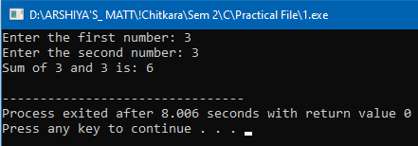

**Result:** This C program uses `stdio.h` for input/output. It prompts the user for two numbers, calculates their sum, and prints the result, showcasing basic input, output, and arithmetic operations.

Practical (2)

**Aim:** Write a program to add two numbers and display the sum.

**Tool Used:** Dev C++

**Code:**

# include<stdio.h>

int main(){

int a,b;

printf("Enter 1st no.: ");

scanf("%d",&a);

printf("Enter 2nd no.: ");

scanf("%d",&b);

printf("%d",a+b);

return 0;}

**Output:**

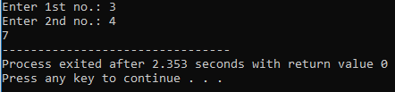

**Result:** The code efficiently takes user input for two numbers and prints their sum. It follows a clear structure and uses standard input/output functions in C.

Practical (3)

**Aim:** Write a program to calculate the area and the circumference of a circle by using radius as the input provided by the user.

**Tool Used:** Dev C++

**Code:**

#include <stdio.h>

#include <math.h>

int main() {

double radius, area, circumference;

printf("Enter the radius of the circle: ");

scanf("%lf", &radius);

area = M_PI * pow(radius, 2);

circumference = 2 * M_PI * radius;

printf("Area of the circle: %.2lf\n", area);

printf("Circumference of the circle: %.2lf\n", circumference);

return 0;}

**Output:**

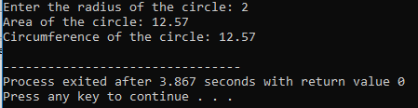

**Result:** This C program efficiently calculates the area and circumference of a circle using the user-provided radius, incorporating the math library for accurate mathematical computations.

Practical (4)

**Aim:** Write a Program to perform addition, subtraction, division and multiplication of two numbers given as input by the user.

**Tool Used:** Dev C++

**Code:**

#include <stdio.h>

int main() {

double num1, num2;

printf("Enter 1st number: ");

scanf("%lf", &num1);

printf("Enter 2nd number: ");

scanf("%lf", &num2);

double sum = num1 + num2;

double difference = num1 - num2;

double quotient = (num2 != 0) ? (num1 / num2) : 0;

double product = num1 * num2;

printf("Sum: %.2lf\n", sum);

printf("Difference: %.2lf\n", difference);

printf("Quotient: %.2lf\n", quotient);

printf("Product: %.2lf\n", product);

return 0;}

**Output:**

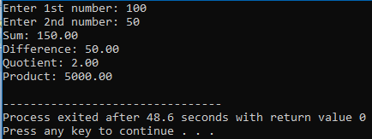

**Result:** This program takes two numbers as input, performs addition, subtraction, division (with a check for division by zero), and multiplication, then displays the results with two decimal places.

Practical (5)

**Aim:** Write a program to evaluate each of the following equations.  
(i) V = u + at (ii) S = ut+1/2at2 (iii) T=2*a+√b+9c (iv) H=√b2+p2

**Tool Used:** Dev C++

**Code:**

1. V = u + at

# include<stdio.h>

int main(){

float u,a,t,V;

printf("Enter u,a,t: ");

scanf("%f%f%f",&u,&a,&t);

V = u+(a*t);

printf("V=%f",V);

return 0;

}

1. S = ut+1/2at2

#include<stdio.h>

int main(){

float u,t,a,S;

printf("Enter u,t,a: ");

scanf("%f%f%f", &u,&t,&a);

S = (u*t)+((a*t*t)/2);

printf("S=%f",S);

return 0;

}

1. T=2*a+√b+9c

#include<stdio.h>

#include<math.h>

int main(){

float c,b,a,T;

printf("Enter a,b,c: ");

scanf("%f%f%f", &a,&b,&c);

T = a*2 + sqrt(b) + 9*c;

printf("T=%f",T);

return 0;

}

1. H=√b2+p2

#include<stdio.h>

#include<math.h>

int main(){

float H,b,p;

printf("Enter p,b: ");

scanf("%f%f", &p,&b);

H = sqrt((b*b) + (p*p));

printf("H=%f",H);

return 0;

}

**Output:**

(i)

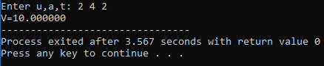

(ii)

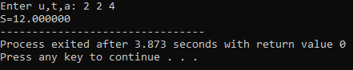

(iii)

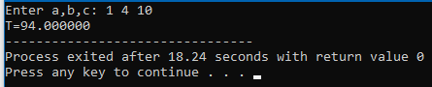

(iv)

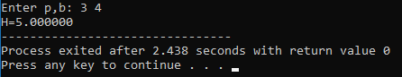

**Result:**

(i) The code calculates final velocity (V) using the formula V = u + at. It takes user input for initial velocity (u), acceleration (a), and time (t), then computes and prints the result.

(ii) This code computes displacement (S) using the formula S = ut + 1/2at^2. It takes user input for initial velocity (u), time (t), and acceleration (a), then outputs the calculated displacement.

(iii) The program calculates a value (T) using the formula T = 2*a + √b + 9c. It prompts the user to input values for variables a, b, and c, computes T, and prints the result.

(iv) This code determines the hypotenuse (H) of a right-angled triangle using the formula H = √(b^2 + p^2). User inputs for base (b) and perpendicular (p) are taken, and the hypotenuse is then computed and displayed.

Practical (6)

**Aim:** Write a program to swap two variable: a) By using temporary variable. b) Without using temporary variable

**Tool Used:** Dev C++

**Code:**

1. Swap two numbers with third variable

#include <stdio.h>

int main() {

int a,b,temp;

printf("Enter a: ");

scanf("%d", &a);

printf("Enter b: ");

scanf("%d", &b);

temp = a;

a = b;

b = temp;

printf("After swapping a = %d and b = %d", a,b);

return 0;

}

1. Swap two numbers without third variable

#include <stdio.h>

int main() {

int a,b;

printf("Enter a: ");

scanf("%d", &a);

printf("Enter b: ");

scanf("%d", &b);

a = a+b;

b = a-b;

a = a-b;

printf("After swapping a = %d and b = %d", a,b);

return 0;}

**Output:**

(a)

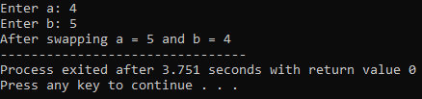

(b)

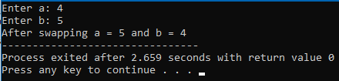

**Result:**

(a) The first code swaps two numbers using a third variable. It takes user input for 'a' and 'b', uses a temporary variable 'temp' to perform the swap, and then prints the swapped values.

(b) The second code swaps two numbers without a third variable using arithmetic operations. It adds 'a' and 'b' to get a new 'a', subtracts 'b' from this new 'a' to get the new 'b', and vice versa. The swapped values are then printed.

Practical (7)

**Aim:** Write a Program to find the greatest among three numbers using Conditional Operator and If-Else statement.

**Tool Used:** Dev C++

**Code:**

#include <stdio.h>

int main() {

int a,b,c;

printf("Enter no.: ");

scanf("%d%d%d", &a, &b, &c);

if(a>b && a>c){

printf("%d is the greatest no.", a);}

else if(b>a && b>c){

printf("%d is the greatest no.", b);}

else if(c>b && c>a){

printf("%d is the greatest no.", c);}

return 0;}

**Output:**

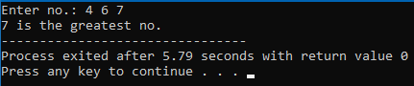

**Result:** This C program determines the greatest among three numbers. It prompts the user to input three numbers, and then uses if-else statements to compare them. The program prints the greatest number based on the conditions. It efficiently handles cases where each number is compared to the others, providing the correct result.

Practical (8)

**Aim:** Write a program using while loop to print the sum of first n natural numbers.

**Tool Used:** Dev C++

**Code:**

#include <stdio.h>

int main()

{ int n,i,sum;

printf("Enter number: ");

scanf("%d", &n);

sum=0;

for(i=1; i<=n; i++){

sum = sum + i;}

printf("Sum of all natural no. till %d is: %d\n", n,sum);

return 0; }

**Output:**

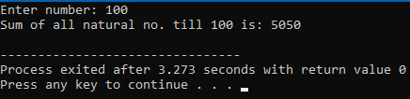

**Result:** This C program calculates the sum of natural numbers up to a given input 'n' using a for loop. It correctly initializes variables, iterates through numbers, and displays the sum.

Practical (9)

**Aim:** Write a program to check a number is Armstrong or not using For loop.

**Tool Used:** Dev C++

**Code:**

#include<stdio.h>

#include<math.h>

int main() {

int n,r,original,n1;

printf("Enter the no.: ");

scanf("%d",&n);

original=n;

n1=n;

int count=0;

while(n!=0){

n=n/10;

count=count+1; }

int sum=0;

while(n1!=0){

r=pow((n1%10),count);

sum=sum+r;

n1=n1/10;}

if(sum==original){

printf("%d is an Armstrong no.",original);}

else{

printf("%d is not an Armstrong no.",original);}

return 0;}

**Output:**

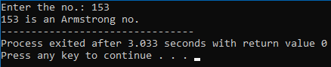

**Result:** This C program determines whether a given number is an Armstrong number. It correctly calculates the sum of each digit raised to the power of the digit count, compares it to the original number, and outputs the result accurately.

Practical (10)

**Aim:** Write the program to count the digits in a number and then print the reverse of the number also.

**Tool Used:** Dev C++

**Code:**

#include <stdio.h>

int main() {

int num, originalNum, digitCount = 0, reversedNum = 0;

printf("Enter a number: ");

scanf("%d", &num);

originalNum = num;

while (num != 0) {

num = num / 10;

digitCount++;

}

num = originalNum;

while (num != 0) {

int remainder = num % 10;

reversedNum = reversedNum * 10 + remainder;

num = num / 10;

}

printf("Number of digits: %d\n", digitCount);

printf("Reverse of the number: %d\n", reversedNum);

return 0;

}

**Output:**

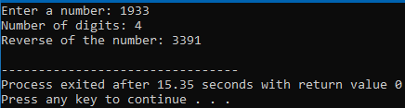

**Result:**

This C program efficiently counts the digits in a number and calculates its reverse. It uses loops to iterate through the digits, maintains count and reversed values, and displays the results accurately.

Practical (11)

**Aim:** Write a program to generate the Fibonacci series.

**Tool Used:** Dev C++

**Code:**

#include<stdio.h>

int fibo(int n);

int main(){

int n;

printf("Enter the no.: ");

scanf("%d",&n);

printf("Fibonacci of %d is: %d",n,fibo(n));

return 0;

}

int fibo(int n){

if(n == 1){

return 0;

}

else if(n==2){

return 1;

}

else{

int fib = fibo(n-2)+ fibo(n-1);

return fib;

}

}

**Output:**

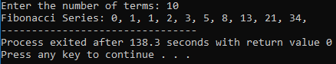

**Result:**

This C program generates the Fibonacci series up to a specified number of terms. It efficiently utilizes variables to represent terms, iterates through a loop to calculate and print each term, providing a clear and concise implementation for generating the Fibonacci sequence.